**Example Run**

## **Installation**

1. Install Anaconda from the official Anaconda website.
2. Open the terminal and run the following command to create a new conda environment: *> conda create -n gputest python=3.9*
3. Activate the conda environment using the following command: *> conda activate gputest*
4. Install gymnasium: *> pip install gymnasium*
5. Install TensorFlow using: *> conda install tensorflow*
6. (Alternative to step 5) *> conda install tensorflow-gpu*
7. Next, we need to install Keras: *> conda install tensorflow.keras*
8. (If step 6) Skip this step if you do not have a dedicated GPU, install cuda using: *> conda install -c nvidia cuda-nvcc*
9. (Completely Optional), for analysis and generating Heatmaps using visualizeModel.py file: *> conda install seaborn*
10. Finally, unzip Raider_Squad_prototype2_V1.zip and extract all the files to get started

## **Batch file integration for training**

To start the training of the agent for phase 2, follow the following steps:

1. Open the terminal in visual studio code
2. Navigate to ./Train/Phase2/: *> cd .\Train/Phase2*
3. Run setEnv to set the environment in conda: *> .\setEnv.bat*
4. Next run tain.bat file to train the agent: *> .\train.bat*
5. From the given prompt select 1 to 4 to train the respective agent.

## **Server.py file for execution integration**

1. For executing the code, follow these steps:
2. Activate the conda environment using the following command: *> conda activate gputest*
3. Navigate to the game directory where this server.py file is located.
4. Run this command: python server.py
5. After point, the directory mentioned, now run the command “runme.bat”
6. On the console, there will be a port number visible for the UI execution. For example, it may be 8000.
7. Type localhost:[port_number] in the browser to open the UI. For example, localhost:8000.
8. After this, you should be able to access the UI, from where all the code can be executed from a single point (integrated).

**Changes in the UI for the final report increment:**

We have added a new agent called Agent Obsidian which is better than Agent Diamond.

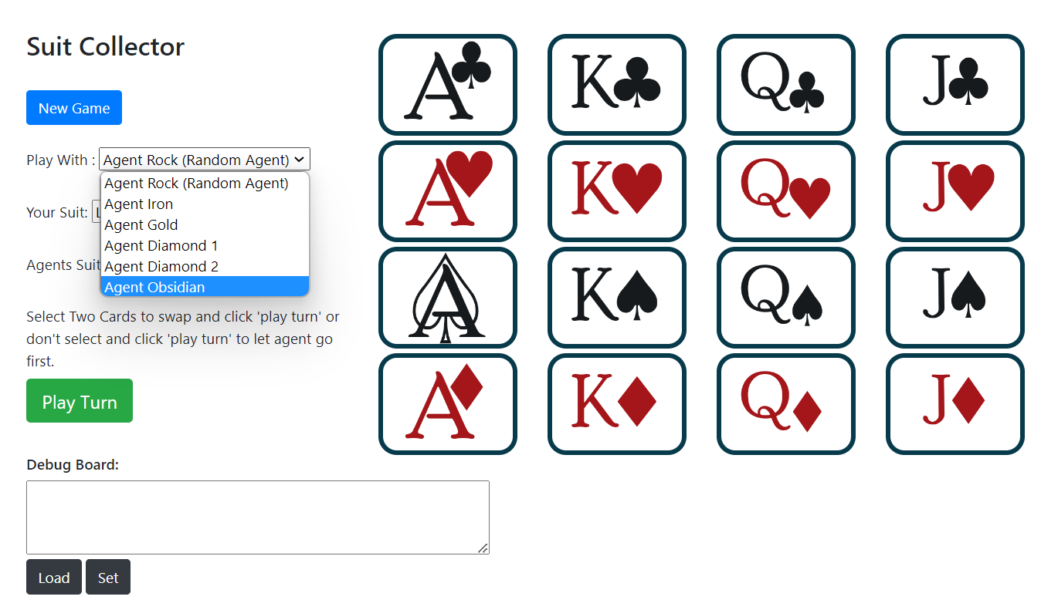

We have also added a new option for picking agent’s suit, which is Pick Suit (Phase 1). This option uses the logic used in phase1.py file to pick the agent’s suit. It is the combined implementation of Manhattan distance reward function and epsilon-greedy with epsilon-decay based on reward function.

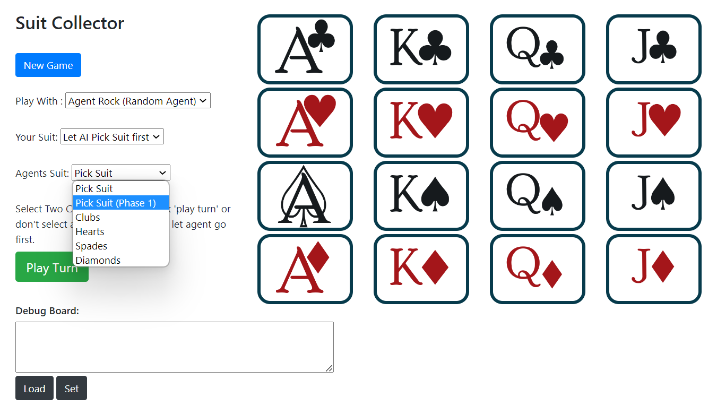

## **Input/Output**

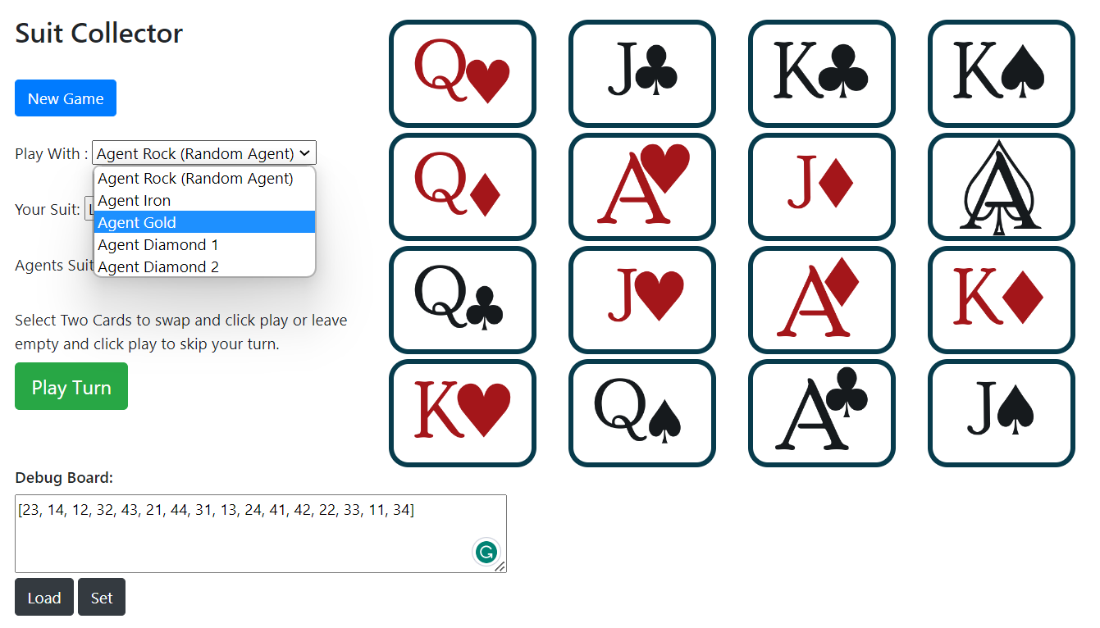

* This is the initial board after generating it randomly. For this we can either click on the “New Game” button or we can also enter the desired arrangement of cards in the Debug board. In this case, the position of the board is represented by the following array:
  + [23, 14, 12, 32, 43, 21, 44, 31, 13, 24, 41, 42, 22, 33, 11, 34]
* After entering this array in the debug board dialog box, press the Set button. This will arrange the board in the desired position.
* We pick an agent of our choice in the Play With drop down menu. Here we have chosen Agent Gold.

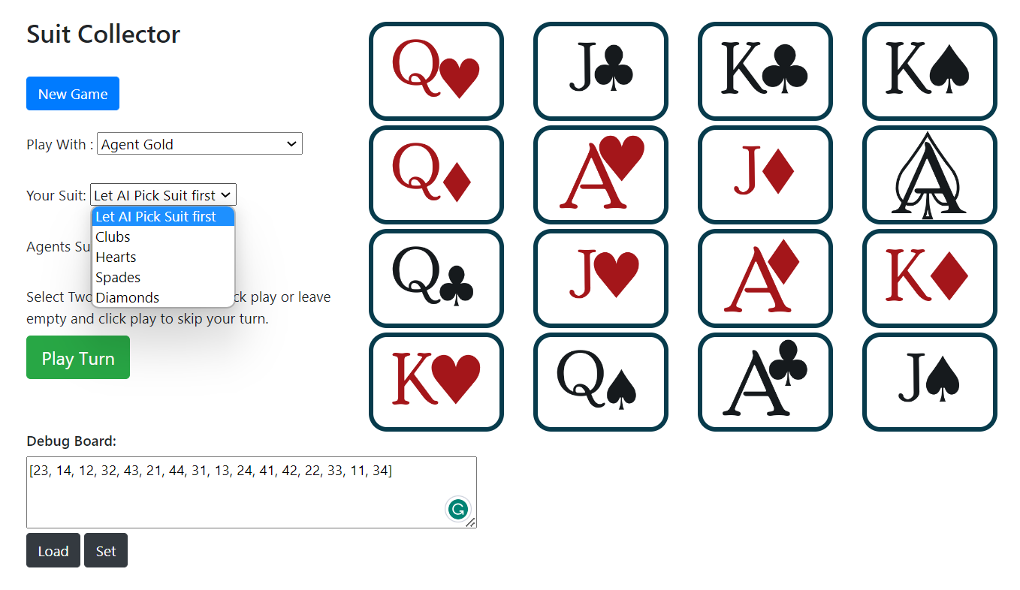

* After that, we let the agent pick the suit before we pick a suit for ourselves. To do that, select “Let AI Pick Suit first” option in the Your Suit dropdown menu.

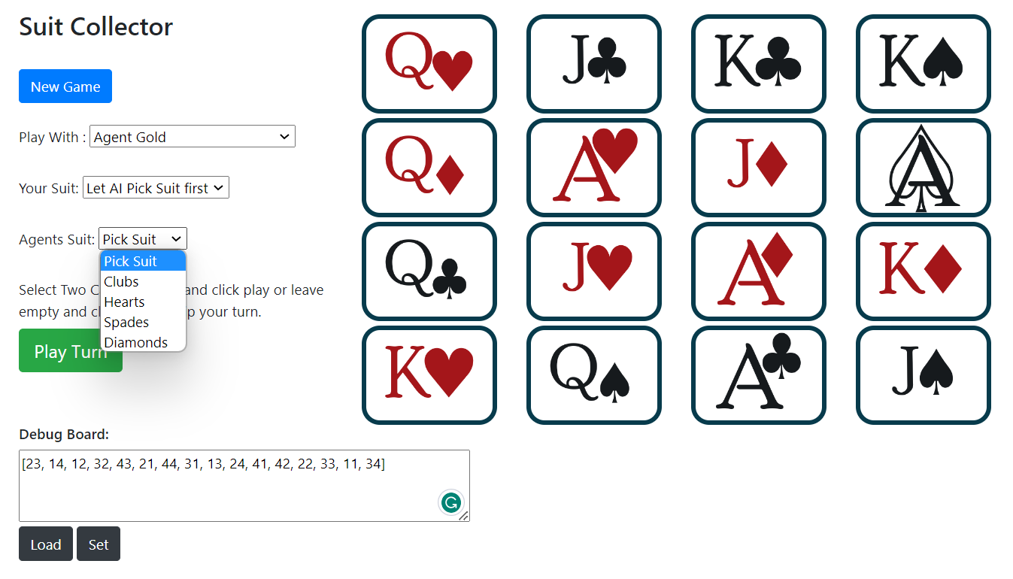

* After that, pick “Pick Suit” option in the Agents Suit dropdown menu.

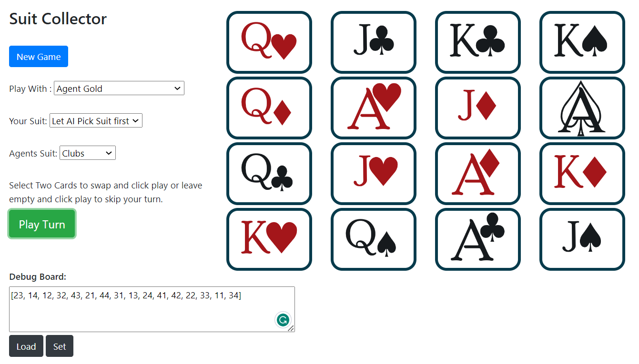

* After clicking the Play Turn button, the picked suit by the agent is reflected in the Agents Suit dropdown.

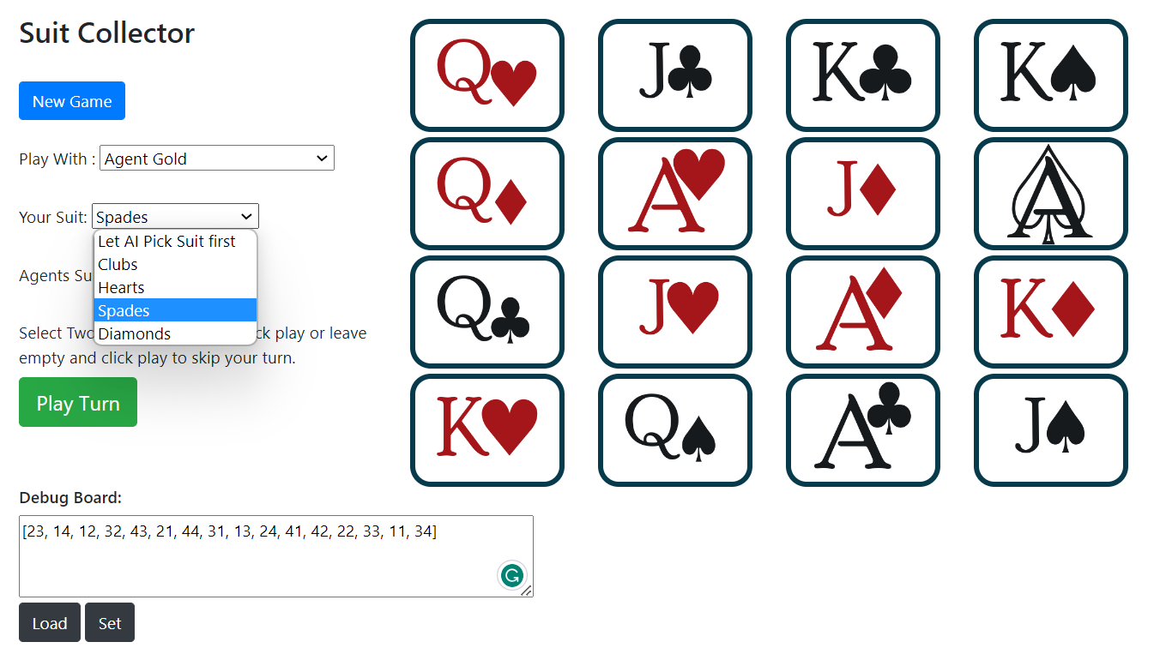

* After that, the user must pick a suit. Here we pick Spades.

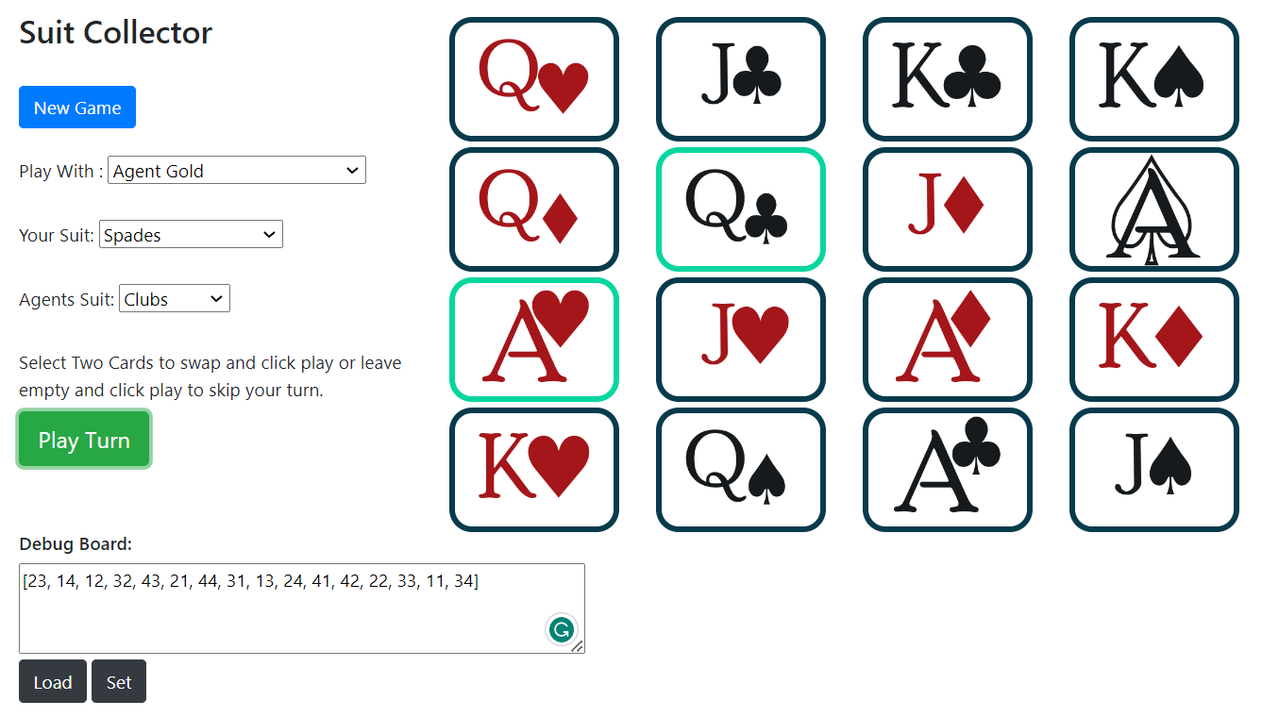

* After picking the suit for the user from Your Suit dropdown menu, click on the Play Turn button. This will prompt the agent to make the first move. Here the agent chose to swap Ace of Hearts with Queen of Clubs. The cards swapped by the agent are highlighted in the green border.

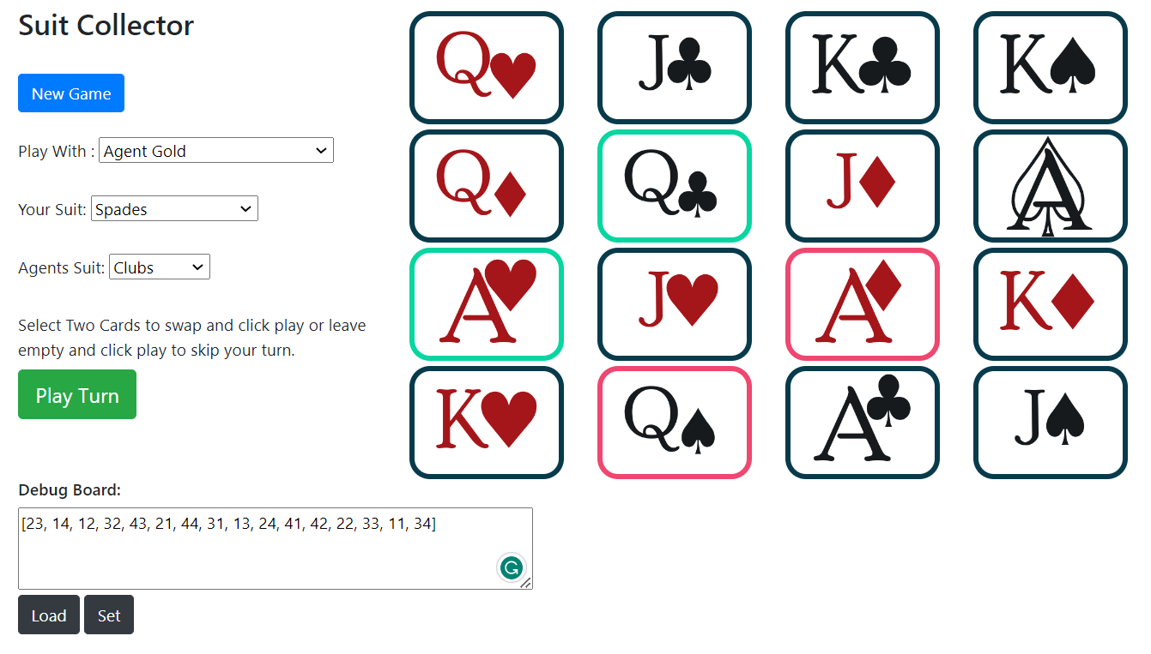

* It’s our turn to play now. We click on two cards (here those are Queen of Spades and Ace of Diamonds). User’s cards are highlighted in the red border. We must click on these two cards and then the Play Turn button.

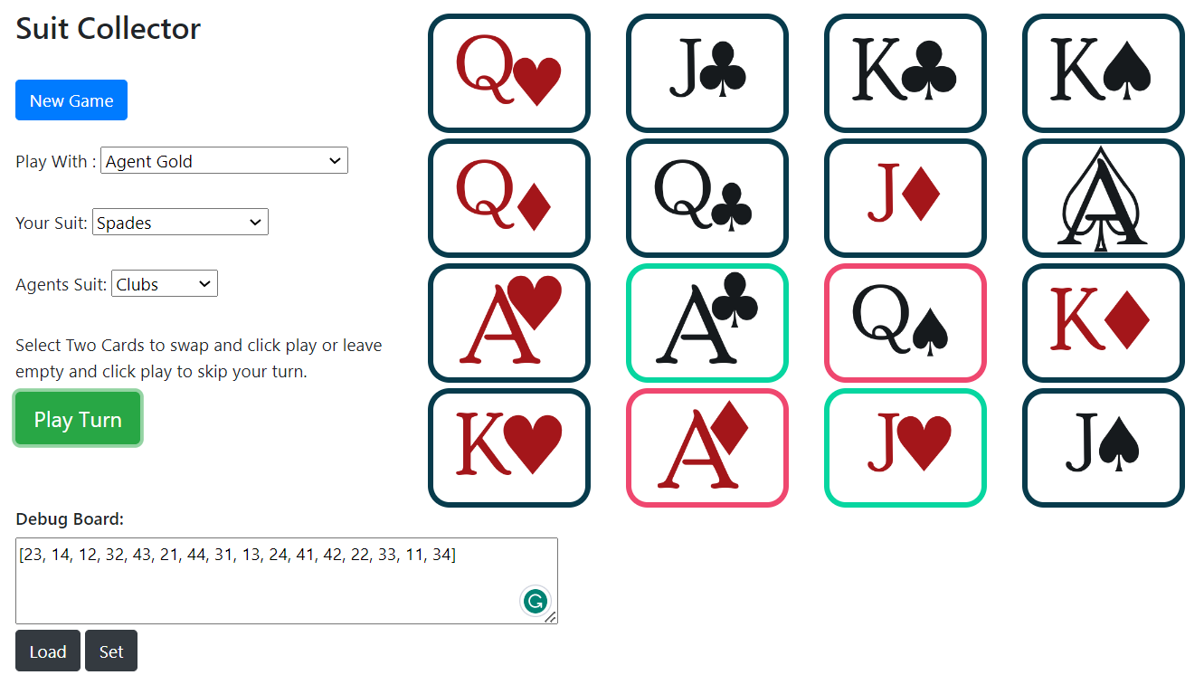

* After that, the cards will be swapped and then the agent will play its move.

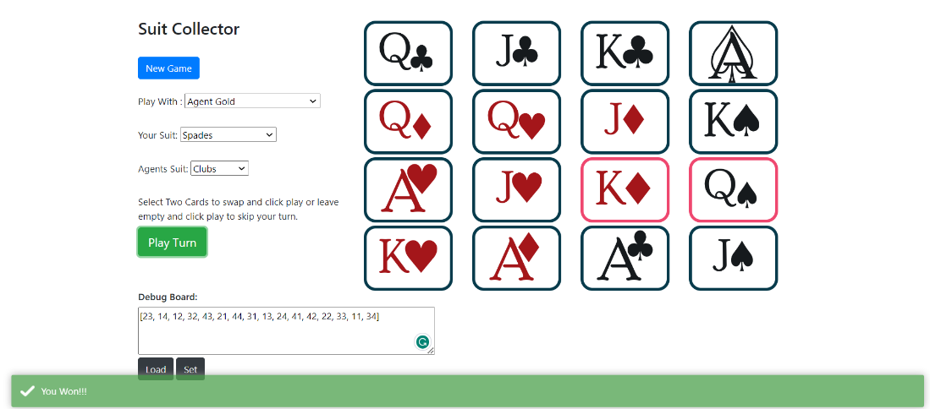

* The game will go on till either the agent wins or the user wins. Here in our case, we win!!!
* This message is shown as an alert in the green box at the bottom of the screen.

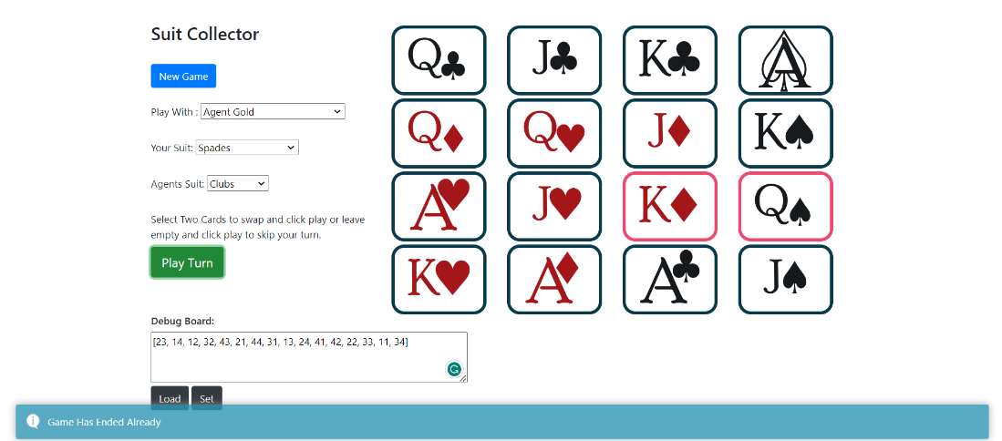

* If we try to make a move after the game is over, we get another alert in the blue box saying the game has already ended.

## **Description of UI**

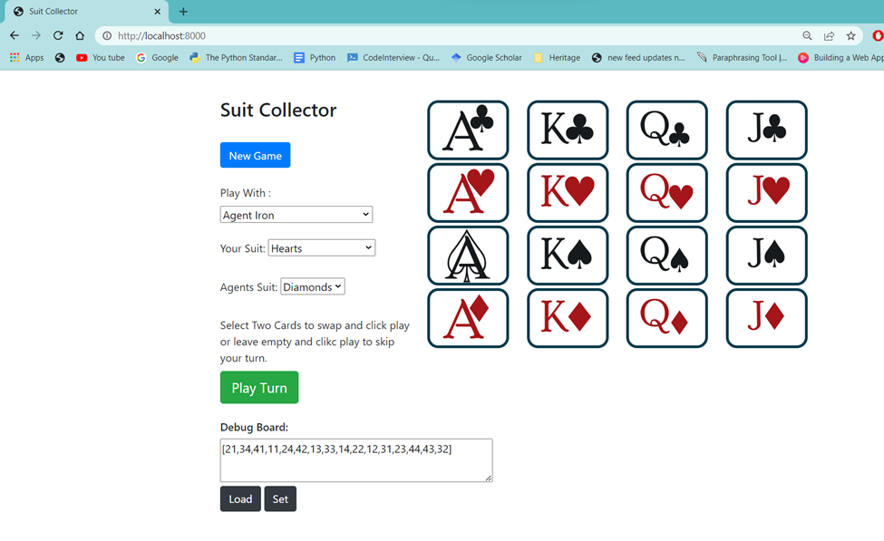

* This is our user interface. Here the play grid is of 4x4 size which has 16 cards in total. Initially, when we start the server.py file and execute it, we must go to the browser and type localhost:[port_number]. This port_number is available on the console output when we run the server.py file.
* After following the above steps, we get this above picture on our browser. Initially it shows all the suits in sequence starting from Clubs, Hearts, Spades, and Diamonds.
* On the left side we see a blue button saying, “New Game.” After we click this button, the sequence of the cards on the right side is randomized and the board is shuffled, ready to play.

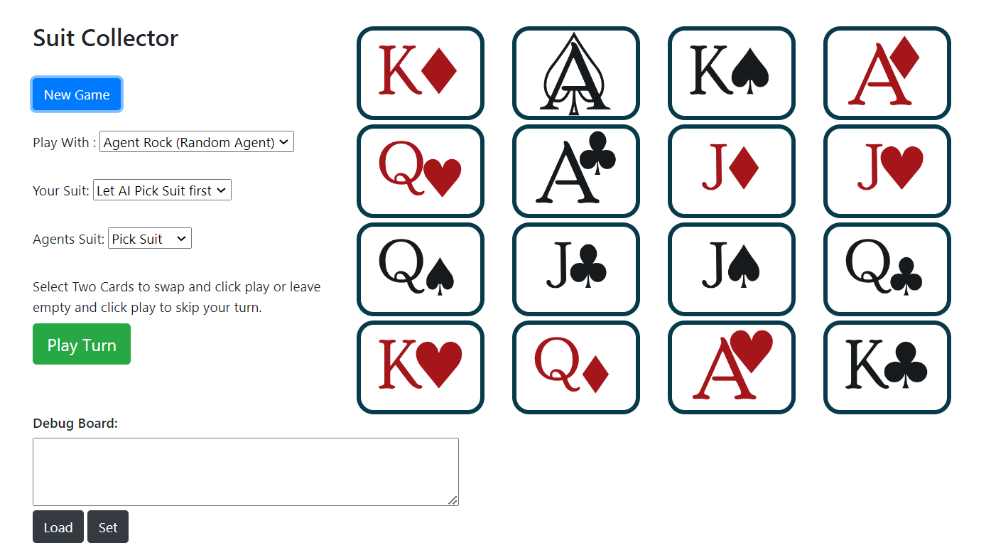

* This is the board which will go to the server.py and to game.py file from there. The representation of this board in list format is as follows:
* [42, 31, 32, 41, 23, 11, 44, 24, 33, 14, 34, 13, 22, 43, 21, 12]
* There is one drop down menu below the New Game button which is “Play with.” In this drop down, there are following options:

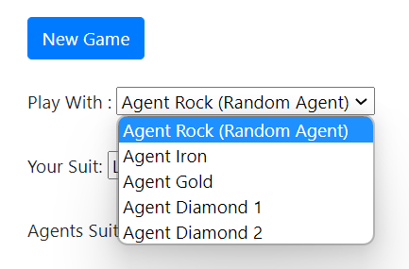

* These different agents are the various iterations of the code which are greater in performance than the preceding ones. Agent Rock is the random agent which will pick any random suit and play any random action while playing.
* The user can select any of these agents to play with.
* Below that there is one more dropdown menu called “Your Suit.” This has the following options:

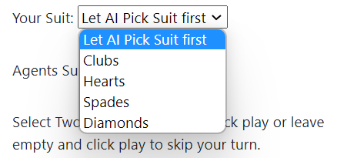

* Here the first option is “Let AI Pick Suit First” is for letting the agent pick the suit first. If the user wants to let the agent pick the suit before themselves, then they will have to select “Pick Suit” option in the third dropdown menu as well.
* The rest of the options are for the suits that the user may pick according to their wish if they want to go first.
* The last dropdown menu is “Agents Suit.” It has the following options:

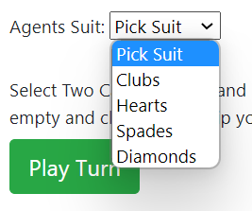

* The first choice is chosen by the user if they want to let the agent choose the suit for himself. Otherwise, if the user picks one of the suits, then that would be a manual selection.
* The green button “Play Turn” would be the next one to click on. After the user has clicked on it, the suits will be picked if not done before, and the agent will play its first move. After that, the user will be prompted to make the next move. For that, the user must click two cards and click on “Play Turn” button again. This is shown in detail in the test case and output video.

## **Test cases**

Video 1: (user wins)

Played with Agent Rock and won against it, which is a random agent.



Video 2: (user wins)

Played with Agent Iron and won against it.



Video 3: (agent wins)

Played against Agent Iron and when it plays against a beginner it makes them lose as well, this shows our model’s integrity.



Video 4: (user wins)

Played against agent Gold and won



Video 5: (User wins)

Played against agent Diamond-1 and won.



Video 6: (user wins)

Played against agent Diamond-2 and won.

Diamond-2.



Video 7: (agent wins)

As the model is trained further, our latest agent has gotten some good moves which made us lose when played against it. As it’s now familiar with blocking the human’s moves.

Diamond-2.

